Second part of duodenum

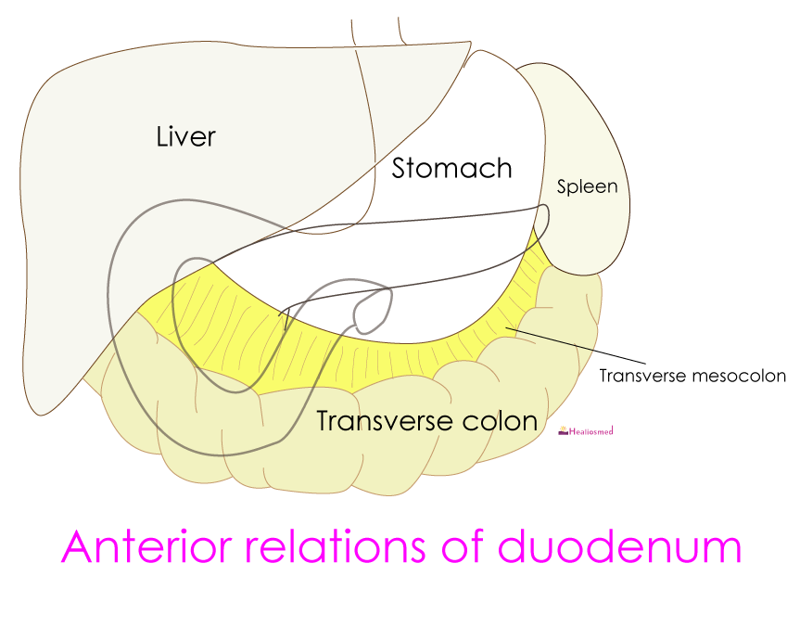
Anterior and posterior relations

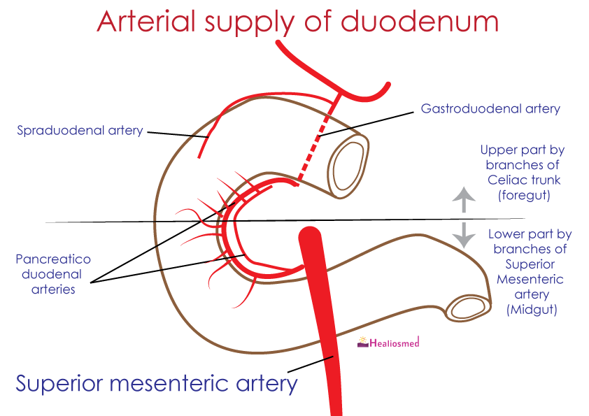
Arterial supply of duodenum

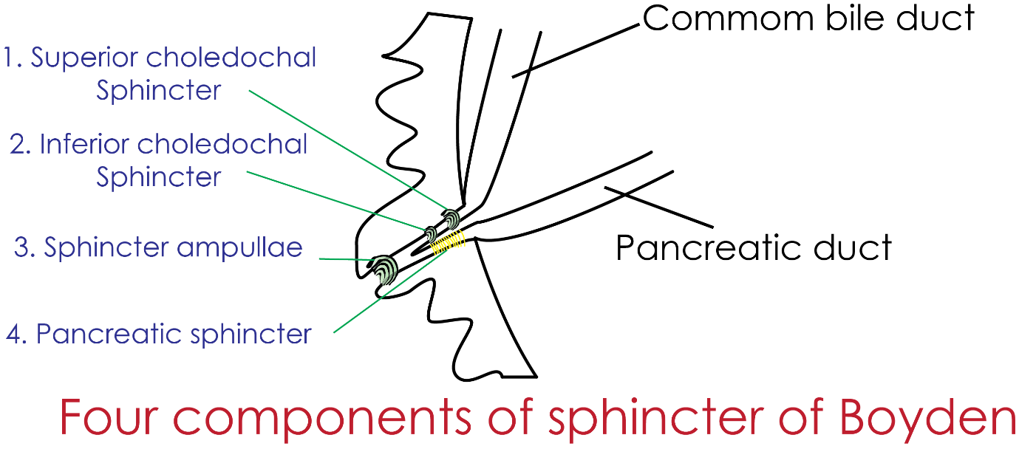
Interior of second part of duodenum

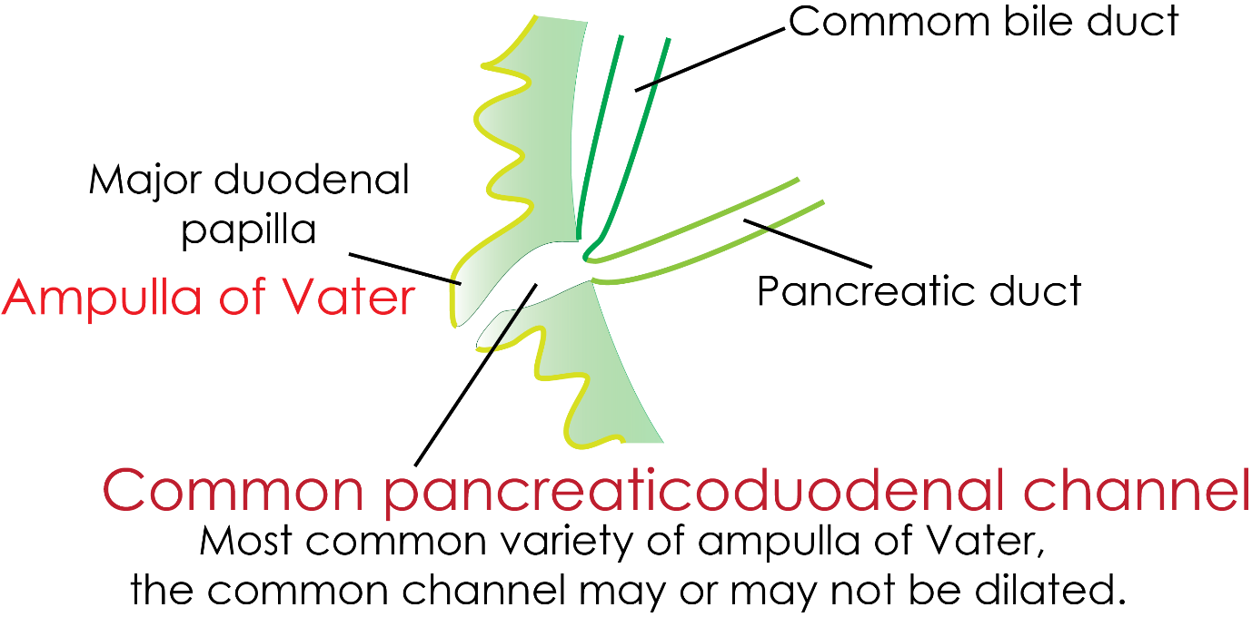

Common Pancreaticoduodenal Channel

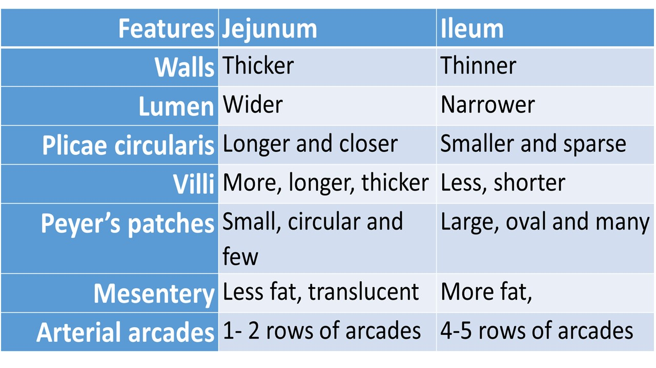
Difference between jejunum and ileum

Endoscopic retrograde cholangiopancreatography
It is the technique of injecting radiocontrast material into the pancreatic and bile duct through major duodenal papilla for the diagnostic and therapeutic purposes

